Modification & Changes from Journal Paper

The basic objectives of my thesis was to reproduce the results of the journal paper titled ***“Hierarchical Fuzzy Cooperative Control and Path Following for a Team of Mobile Robots”*** by Hasan Mehrjerdi, Maarouf Saad and Jawhar Ghommam.

It is worth mentioning that we didn’t have access to any of the materials (simulation or hardware) related to the aforementioned paper other than the paper itself. All the implementations and modifications whatsoever are entirely carried out by myself and with the help of my supervisor Dr. Bilal Kadri.

Following are the changes and modifications we did to the journal paper. It also discusses the things which the journal paper did not address and are implemented on our own.

# Control architecture modified:

The journal paper proposed that the fuzzy controller is on the outside of the robots, and there is a single fuzzy controller for all robots. As can be seen from figure 1.



Figure 1 Experimental Setup of journal Paper

The control scheme implemented in this thesis has a separate fuzzy controller for each robot i.e. fuzzy controller is part of the robot. The trajectory generator is common to all, which generates trajectories for all robots. Each robot gets its reference point and its fuzzy controller tracks the desired path as can be seen from figure 2.

Figure 3 shows the inside model of Robot 1 (one of the three identical robots) as can be seen that the reference points are given to the resident fuzzy controller, which generates $v and ω$ for the robot. The linear velocity $v$ output of the fuzzy controller is passed through a low pass filter to reduce high frequency noise which can be harmful for the actuator.

The box named wheel motor controller is the low level PID controller which tracks the left and right wheel motor velocities.

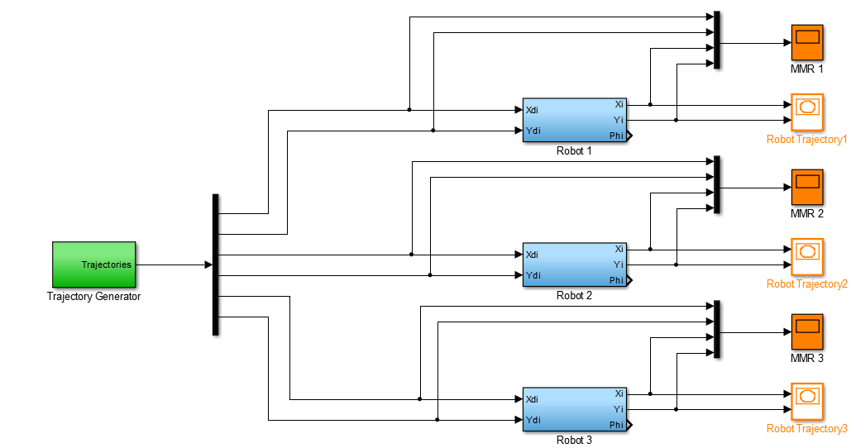

Figure 2 Simulation Setup of Thesis

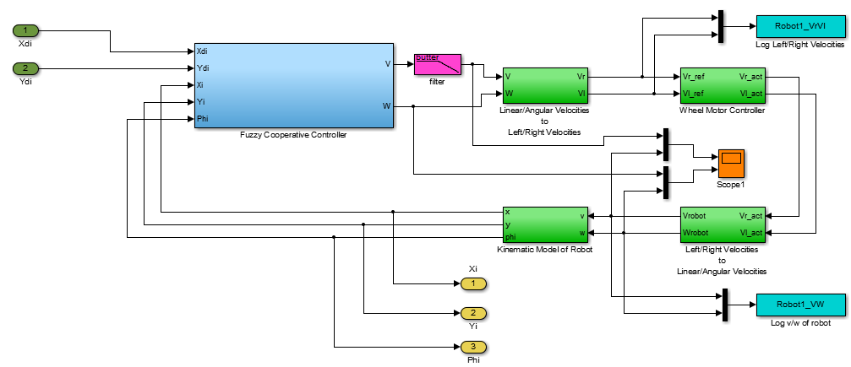

Figure 3 Inside Model of Robot 1

# Fuzzy controller inputs modified:

The journal paper proposed the fuzzy controller with six inputs namely $D_{rp(i)}, y_{err(i)}, X_{err(i)}, α_{i}, L_{i}, ς_{i}$ see figure 4. However, there is no explanation given of how the inputs **Length of path $L_{i}$** and the **path synchronization parameter $ς_{i}$** are used in fuzzy controller nor they are discussed in the fuzzy rule base.



Figure 4 Fuzzy Controller from Journal Paper

In our work we removed the inputs $L_{i}, ς_{i}$ from the fuzzy controller see figure 5, instead we used these two parameters in the trajectory generator. The trajectory generator uses $L_{i}$ to get the length of each robot’s path and divide them in equal number of segments. Whereas it uses $ς_{i}$ to keep count of the path segments and the current segment being executed.



Figure 5 Fuzzy Controller from my Thesis

# Membership functions created and tuned:

Some of the input membership functions were not giving correct results so they were tuned to get optimum results. Also some input membership functions were not given which were created and tuned.

The journal paper didn’t give any information of the output membership functions or equations. The output membership functions were both created and tuned entirely by myself. The output membership functions used in this thesis are constants (0th order Takagi Sugeno equations).

# Modeling and type of wheel motors:

The journal paper did not discuss the mathematical model of wheel motors and what type of DC motors are used.

In our thesis we decided to use Permanent Magnet DC (PMDC) motors for wheels, their modeling and parameter selection is entirely our effort.

# Low level PID controller:

The journal paper did not discuss the implementation of low level PID controller apart from the point that it is being used.

The implementation of the low level PID controller, its tuning is done entirely by myself.